INSTRUCTIONS FOR INSTALLING, TESTING, AND RUNNING LRCD
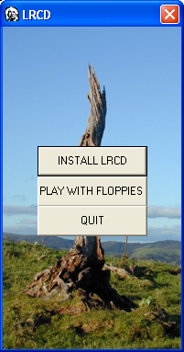
INSTALLING LRCD:
- Insert the CD labeled LRCD in your CD-ROM drive.
- If the menu in figure 1 comes up select INSTALL.
- If the menu in figure 1 doesn’t come up:
  - If your computer uses Windows Vista or Windows 7, select START → PROGRAMS → COMPUTER. Your CD-ROM drive should be labeled LRCD. Select it and find and click on the file GO. This should bring up the menu in figure 1. Select INSTALL. Figure 1
  - If your computer uses Windows XP, select MY COMPUTER. Your CD-ROM drive should be labeled LRCD. Select it and find and click on the file GO. This should bring up the menu in figure 1. Select INSTALL.
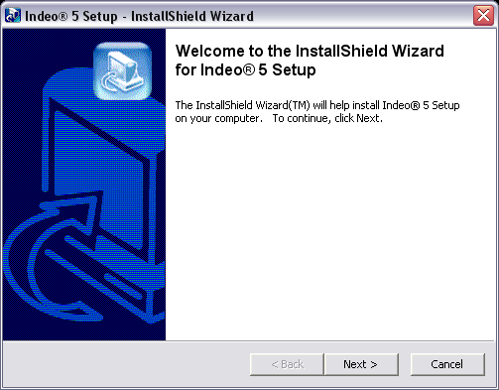
- You should see the menu in figure 2.
  - If you see this menu, select NEXT and follow the instructions on the screen.
  - If you don’t see this menu, when you are finished with the installation, go to the instructions labeled RETESTING below.
- When you see the menu in figure 3, select
OK. Then, when you see the menu in figure 4, click on the computer button. Figure 2
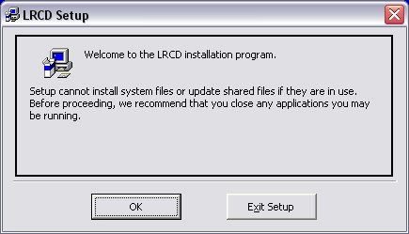
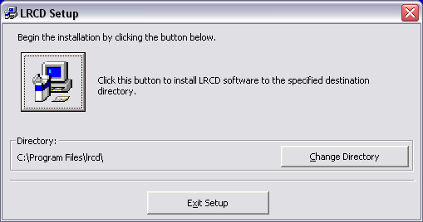

Figure 3 Figure 4
- Follow the directions on the screen until Setup is complete.
- If you are using Windows VISTA or Windows 7, click on your START button, then PROGRAMS, and then LRCD. Click with your right mouse button on the LRCD Einstein icon. A menu will appear—see figure 5. Click on the PROPERTIES option. This will bring up the menu in figure 6. Select the COMPATIBILITY tab at the top of the menu. The menu in figure 7 will appear. Check the box “Run this program in compatibility mode for: Windows XP (Service Pack 2) and the box “Run this program as an administrator. To check these boxes you must enter Windows as an administrator. Click on the APPLY button.
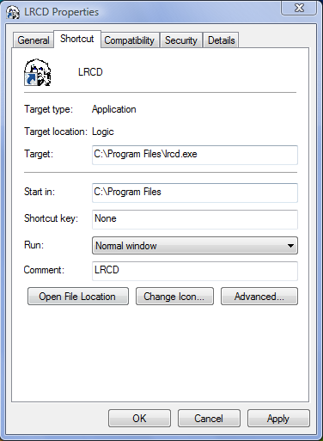
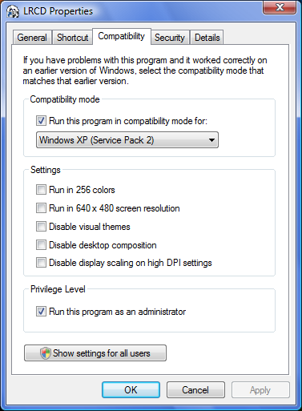
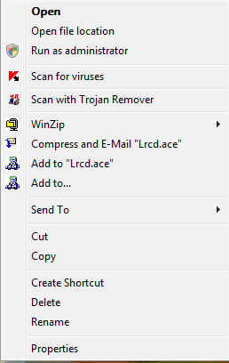

Figure 5 Figure 6 Figure 7

- Start the LRCD program by going to START → PROGRAMS → LRCD and clicking with your left mouse button on the Einstein icon. When the menu in figure 8 appears, click on I AGREE. Then, when figure 9 appears, type your first and last name in the two boxes and click OK.
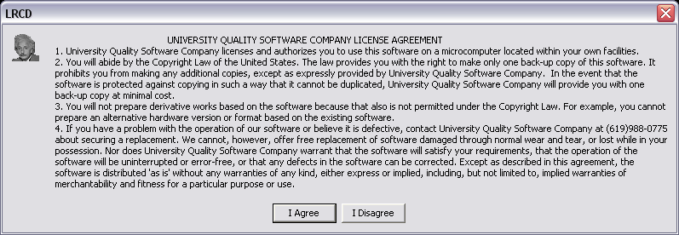
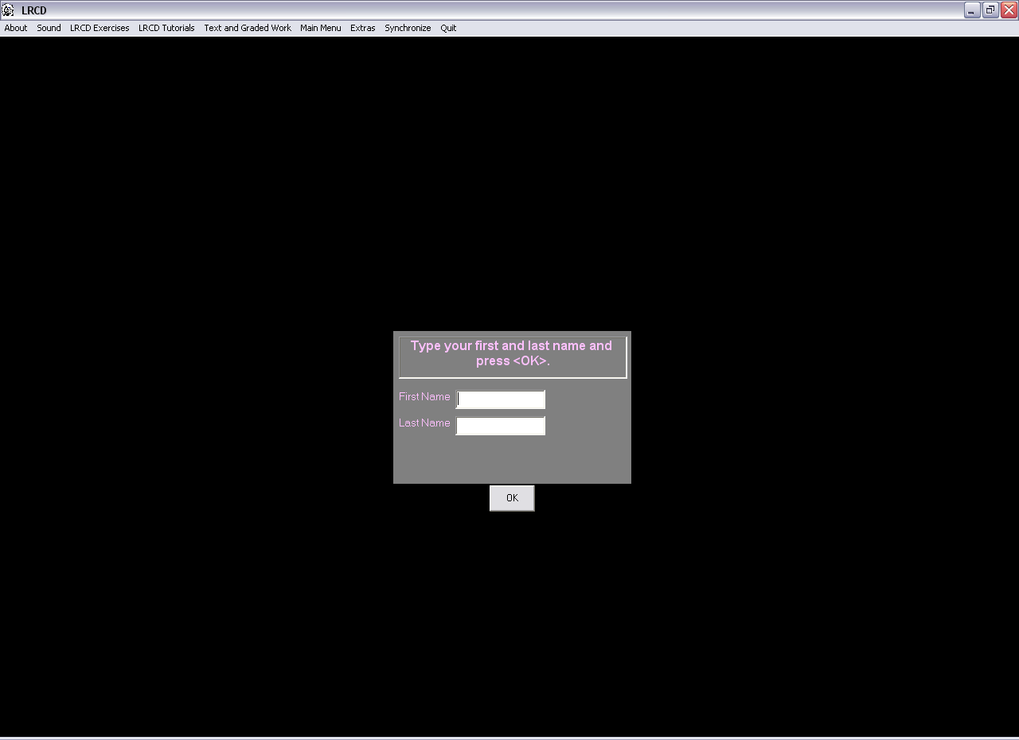
Figure 8 Figure 9
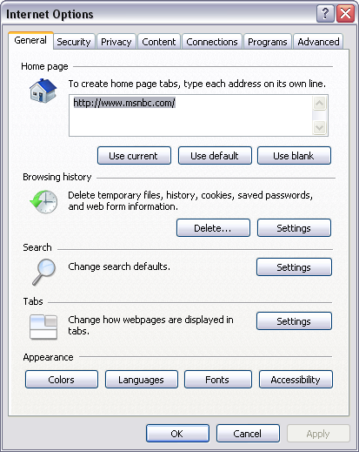
- The program should now run through a series of tests to determine whether or not your computer can: (a) Write to files, (b) Appear full-screen in color during exams 2 through 5, and (c) Access the Internet. If any of these tests fail, you will need to contact tech support at (619)988-0775 in order to fix the problem, and then run the test described in RETEST below.
- If you are going to take examinations on the CD you need to confirm that you have set your computer up to have a default browser. To make INTERNET EXPLORER your default open INTERNET EXPLORER and select the TOOLS button at the top of the page, and then select INTERNET OPTIONS. The menu in figure 10 will appear. Select PROGRAMS and click the MAKE DEFAULT button under the DEFAULT BROWSER section.
Figure 10
- Check your Firewall Security Settings. Go to START → CONTROL PANEL → INTERNET OPTIONS. Click on SECURITY TAB and select either CUSTOM or DEFAULT, whichever is applicable, and make sure the DEFAULT SECURITY LEVEL is set no higher than “Medium-high.”
RUNNING LRCD:
- When running LRCD, if the program doesn’t start automatically when the CD is inserted, always start the program by selecting START → PROGRAMS → LRCD and clicking on the Einstein icon with your left mouse button. Never start it by clicking on the PLAY button in figure 1 above unless you have been given a special set of LOGICAL REASONING floppy disks.
- To get to a set of graded exercises, proceed in either of the following ways:
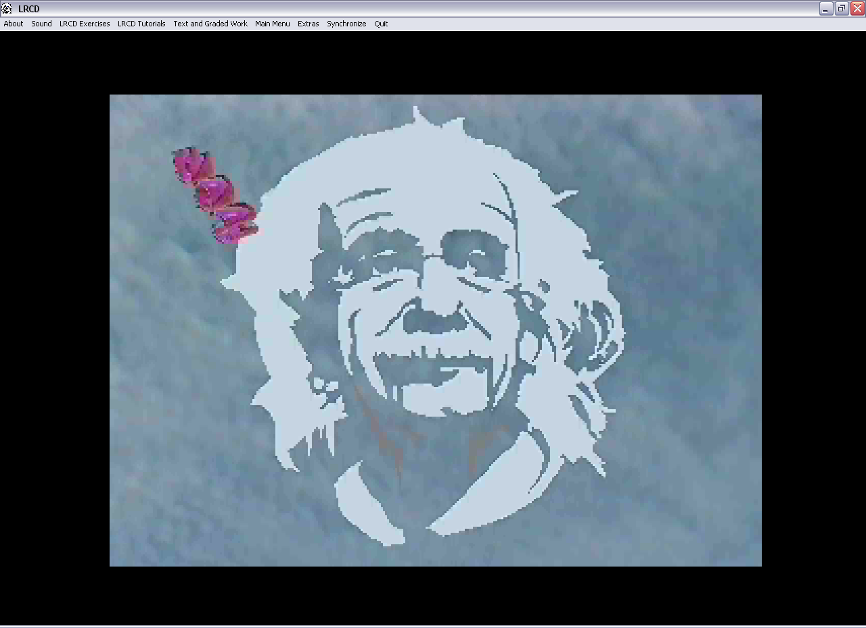
  - When the Einstein video begins (see figure 11) click on the TEXT AND GRADED EXERCISES button at the top of the page, and select the chapter you want. A page will appear (see figure 12) containing the textual material for the chapter you have selected. At the top of the page select the button labeled “GRADED EXERCISES.” Do not select the “LRCD EXERCISES” button if you want to do graded work.
Figure 11
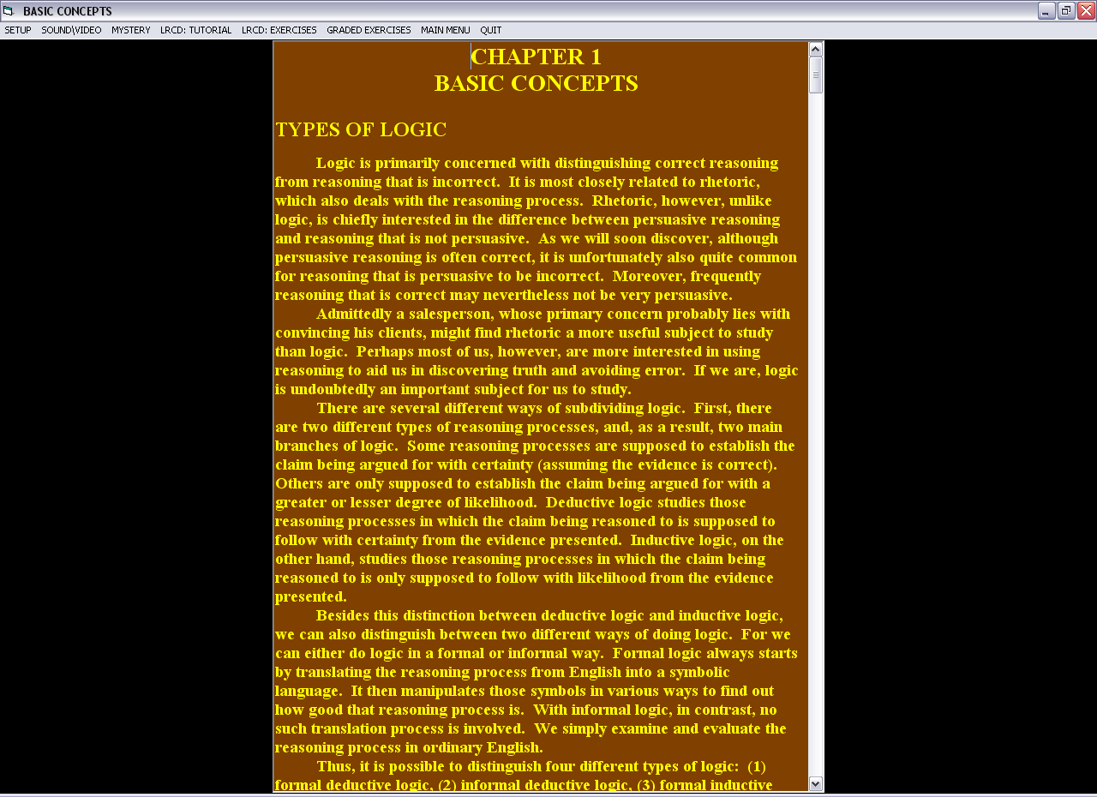
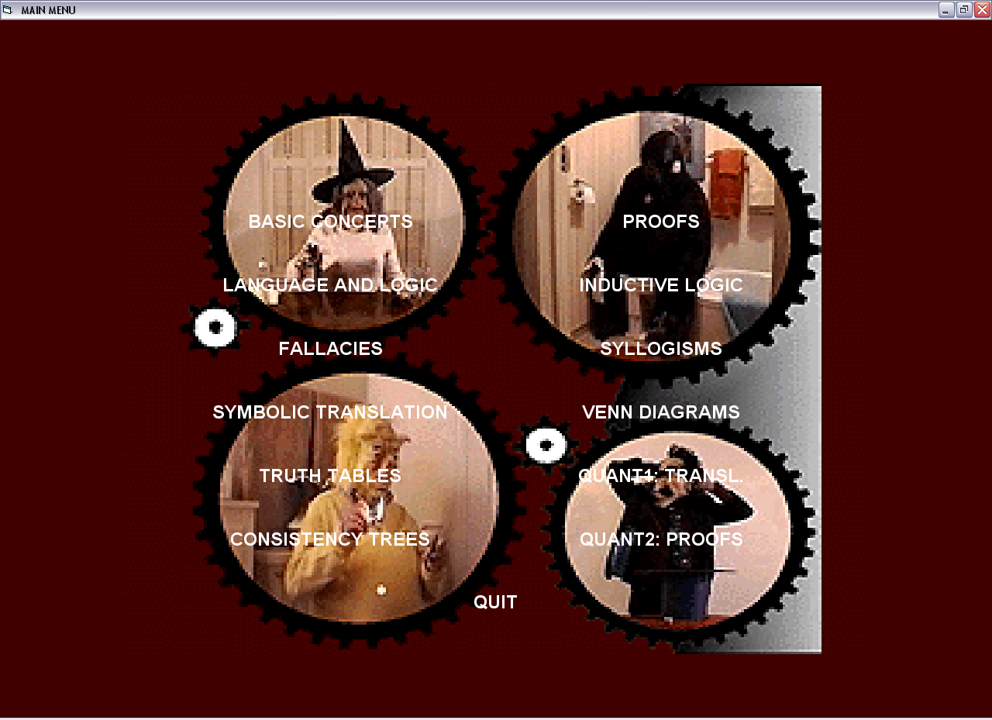
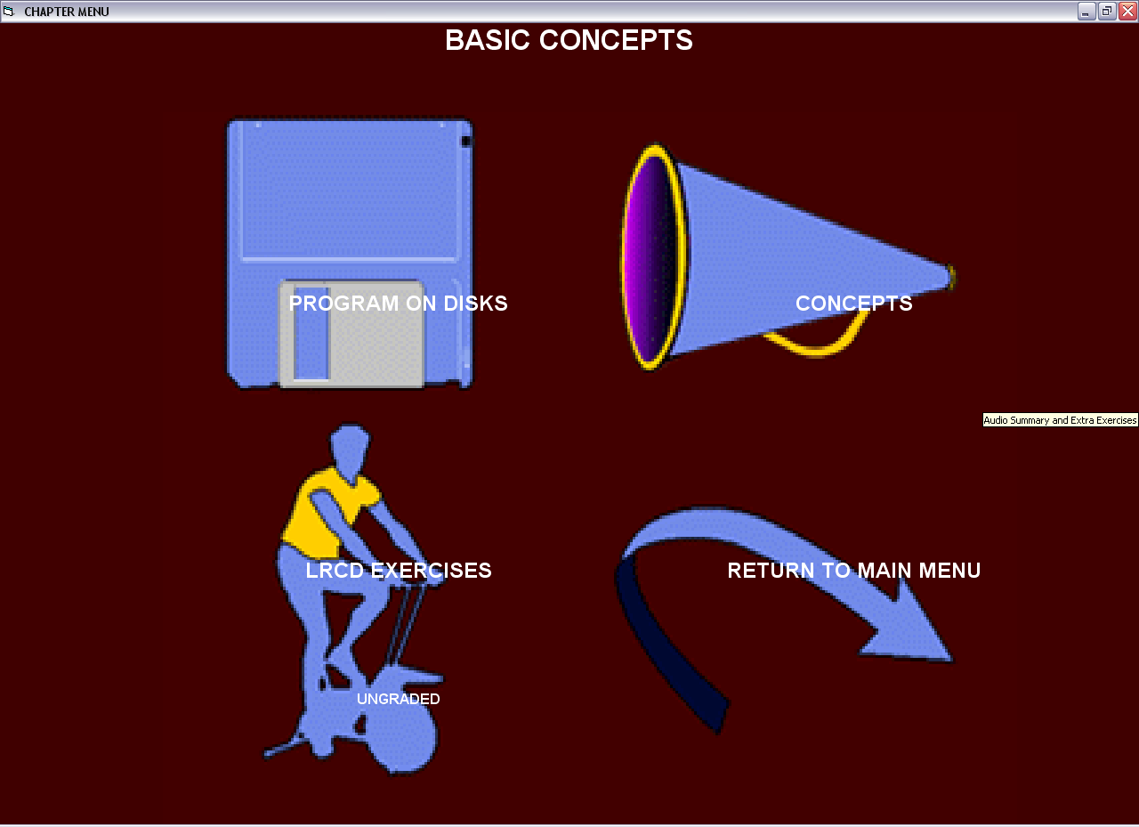
  - When the Einstein video concludes and the page in figure 13 appears, select the chapter you want to go to. Then select the PROGRAM ON DISKS option when figure 14 appears. A page will appear (see figure 12) containing the textual material for the chapter you have selected. At the top of the page select the button labeled “GRADED EXERCISES.” Do not select the “LRCD EXERCISES” button if you want to do graded work.
Figure 12
Figure 13
Figure 14
- To get to an exam, proceed exactly as you do when you go to a set of graded exercises, except select EXAM at the top of the page. Note, however, the exams only exist in some of the chapters (viz., in Fallacies, in Consistency Trees, in Proofs: Main, in Proofs: Other, in Venn Diagrams, in Quantification Theory Proofs: Main, and in Quantification Theory Proofs: Other.)

RETESTING:
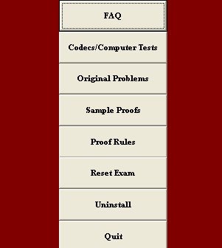
To retest the program at any time, start LRCD and when the Einstein video begins (see figure 11) select EXTRAS. The menu in figure 15 will appear. When it does, select CODECS/COMPUTER TEST. Follow the instructions on the screen. If you have already installed the Codecs, when figure 2 appears select CANCEL and continue with the remaining tests. If you don’t see figure 2 and you haven’t ever installed the Codecs, you need to click with your right mouse button on your CD-ROM drive, select the “Explore” option, then go to the SETUP folder and click on “iv5setup.exe.” If this fails to install the codecs, as it will on some Windows Vista and Windows 7 machines, go to the website www.free-codecs.com/K_Lite_Codec_Pack_download.htm and download the K-Lite Codec Pack Full, and install all the Cinepak and Indeo Video files listed. Please let us know if any of the videos fail to play after these codec packs have been installed.
Figure 15

UNINSTALLING:
To uninstall the program using the Uninstall option, start LRCD and when the Einstein video begins (see figure 11) select EXTRAS. The menu in figure 15 will appear. When it does, select UNINSTALL. If you uninstall the program using Windows Uninstall feature in the Control Panel some data files will not be removed.

POTENTIAL PROBLEMS:
At present most of the problems we are having are related to either installing the program, or getting it to access exams. If you are using Windows Vista or Windows 7 and have installed the program, but you either don’t see videos or the program cannot access exams, try turning off UAC (User Account Control)—which can be found in the control panel—and rerunning the install program by right clicking on the drive containing LRCD, selecting “Explore,” and then clicking on the file “Go”. When the installation is complete you should turn UAC on again.

If you try to access an exam and are told that the file MSSTDFMT.DLL is missing, copy it from the LRCD directory on your CD-ROM drive to C:\Windows\SysWow64\, if that folder exists, or to C:\Windows\System32\, if it doesn’t. Then turn off UAC and go to “Start” (and “Run” if necessary) and type in either the command:
“regsvr32 C:\Windows\SysWow64\MSSTDFMT.DLL”
or
“regsvr32 C:\Windows\System32\MSSTDFMT.DLL”
(without the quotes but with the single space after ‘regsvr32’), whichever is relevant. Turn on UAC when you are finished.
If you can’t access an exam turn off UAC before taking it, and then turn it on again after you are finished.

